Magento Connector V3

**Release Notes (Aug-Dec 2022)**

**Acumatica Integration**



Published on 27/01/2023

#### Version 3.0

Icon  Description automatically generated 877-536-7486

fusionrms.com

**Contents**

Release Notes Information 3

Acknowledgements 3

Notice 3

New Features and Enhancements 4

Known Bugs and Issues 4

Fixes 4

UI Changes 6

Installation Changes 7

# Release Notes Information

|  |  |
| --- | --- |
| Software Name | Acumatica-Magento Connector |
| Version Number |  |
| Release Type (Initial/Minor/Intermediate/Major) | Major |
| Compatible Acumatica Editions | Retail-Commerce   * 2021 R1 * 2021 R2 |
| Package Location | Product Documentation Site: <https://docs.fusionrms.com/> |

## Acknowledgements

Acumatica 2022 R1, R2, and Acumatica Commerce Edition are registered trademarks of Acumatica Inc. All Rights Reserved.

Magento is a registered trademark of Adobe, Inc. All Rights Reserved.

## Notice

The information contained in this document is subject to change without notice.

Fusion Software LLC shall not be liable for any errors or for incidental or illegal acts in connection with the use of these release notes.

Reproduction, adaptation, or translation of this document is prohibited without prior written permission of Fusion Software, except as allowed under copyright laws. All Rights Reserved.

# New Features and Enhancements

|  |  |
| --- | --- |
| New Feature/Enhancement | Which platform has a new feature/enhancement? |
| Magento connector allows its consumers to work on multi-node servers via Magento Cloud; in the past, consumers could only access Node 1. | Magento |
| Through the introduction of a setup enabling Kit Qty sync with options, inventory values passing from Acumatica are now replicated w.r.t warehouse specific parameters such as default Kit Quantity and Kit Components Qty. | Acumatica |
| The PX-CbApiBusinessDate header was added to the Order Sync process to ensure that the Business date was set appropriately to avoid shipment errors for Orders that were synchronized after the BusinessDate. | Magento |
| Sync rules feature is now enabled, allowing businesses to manage their stock across warehouses and multiple stores. Admin users can configure new customized rules to be used as a condition for executing specified activities. | Magento |
| The Last Sync Date value at the product level currently controls if inventory sync occurs; this value is obtained by getting the data from the Magento backend database and applying the logic for the warehouse locations, sales allowed, etc. | Magento |
| When creating a payment, the Magento Order ID will now be included as a parameter. | Acumatica |
| If an order placed in Magento does not have a shipping address, e.g., a digital product, the order can now be synced with Acumatica. | Magento |
| The Enabled Features grid is now editable for users. |  |
| API calls from Magento to Acumatica for Orders, Tax, and Payment Creation have been consolidated to a single API call from Acumatica version 20.200.001 and above. | Acumatica |
| Within Tax Zones, a new feature has been added that allows you to toggle on “Recalculate Tax on Order Edit. | Magento |

# Known Bugs and Issues

# Fixes

* A bug was fixed for the line item that has no tax; the connector considered the same line sum as total tax and presented the Taxable amount to Acumatica in the Tax details tab.

* A bug was fixed for an order that had several shipments, previously, the Batch process submitted only for the first shipment to Magento.
* A bug was fixed in which an invalid join condition on the GI was causing the GI and the syncs to fail.
* A bug was fixed in which an invalid condition triggered a call to S3 even if CommercePro was not enabled or published on the instance.
* A bug was fixed in which a customer sync was not enabled, however, a call still got triggered in Magento on Customer deletion.
* A bug was fixed for an order that was created with a customer address; it saved the customer address id as a reference in the Magento order address databases. In any case, deleting that customer address in Magento resulted in the following error: No such entity with addressId = 170643.
* A bug was fixed in M-A order sync for a product that is already deleted in Magento and when trying to sync with Acumatica triggered an exception call to a member function getSku() on null
* A bug was fixed when Sales Prices are not removed in Magento even after the expiry date
* A bug was fixed on the Customer GI relations auto updates when settings changed in Setup parameters
* A bug was fixed for the Sales Price that saved with both past and future dates at the same time in Acumatica, this resulted as future dates in Magento
* A bug was fixed for the columns that were not loading Product Data Retrieval, Template Item Sales Price, and Inventory details; while it loaded only for child items and same is updated in Magento
* The issue with configured manual numbering sequence that showed differently in Acumatica and Magento is now fixed
* A bug was fixed for the attribute that is mapped with Substitute id and unable to sync template item from Acumatica to Magento and passed the Substitute Ids in the Product JSON
* A bug was fixed for an order that was placed in Magento for an instance between 8.00 PM to 11.59 PM EST, while it is syncing in Acumatica the order was created for the next date, due to the shipment creation failed, when we try to create a shipment on the same day, the order shipment pointed to next day

# UI Changes

A Sync rule option is added under Configuration with conditional arguments and their related value fields.

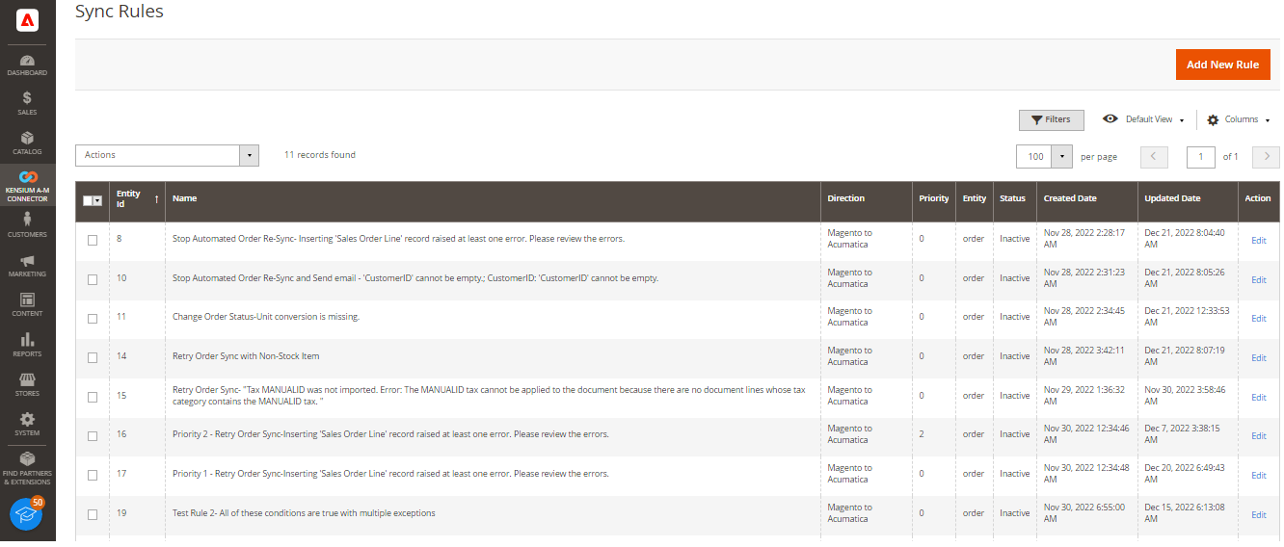

The S3 image sync option is now removed from the Setup Parameters screen when CommercePro is not published.

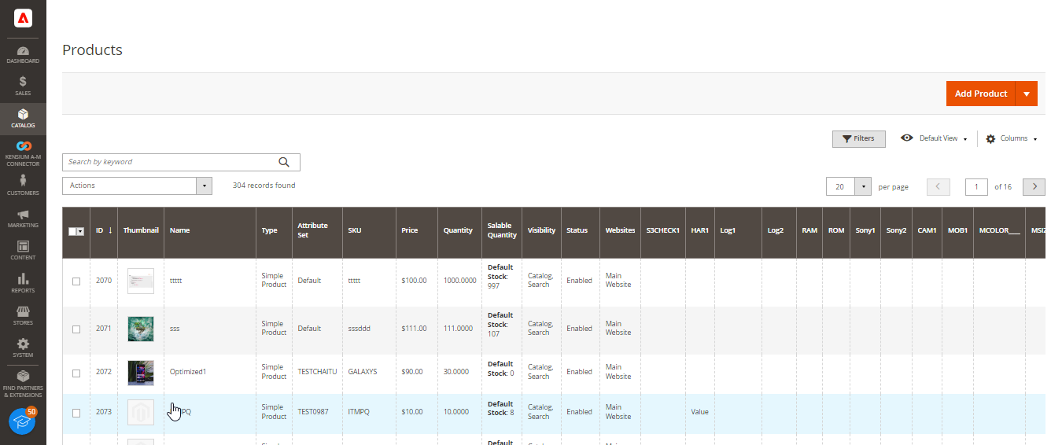

# Installation Changes

There are no installation changes in this release.